 

ASSIGNMENT ON INTERNET TECHNOLOGY(IT)

Assignment Weightage & Type

60% Portfolio Coursework

Corse: BSc (Hons) CS & DF (Sem_2)

NAME: AMAN YADAV

STUDENT ID: 10722

INTRODUCTION TO INTERNET

**WEEK 1**

TASK

Network: Internet is a network of computer linking many different types of computer all over the world. It makes it possible for millions of users to connect to one another via linked by a broad array of electronic, wireless, and optical networking technologies.

INTERNET

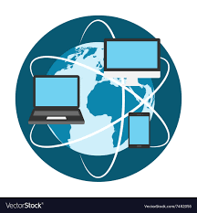

How did the Internet developed?

* Developed in 1960’s
* The internet has its root in the ARPANET system of the Advanced Research Project Agency of U.S. Department of Defense which linked together mainframe computers to form a communication networks.
* ARPANET is known as the forefather of internet.

SERVICES OF INTERNET BASIC

* ELECTRONIC MAIL
* FTP
* TELENET
* USENET NEWS
* THE WORLD WIDE

1. ELECTRONIC MAIL: Electronic mail (e-mail) is a computer-based application for the exchange of messages between users. A worldwide e-mail network allows people to exchange e-mail messages very quickly. It is faster than paper mail at once user can send image, video, audio can be sent at once.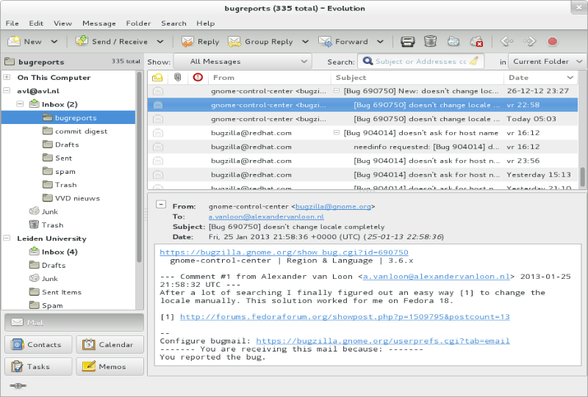
2. FTP(File Transfer Protocol)

File transfer protocol (FTP) is a way to download, upload, and transfer files from one location to another on the internet and between computer systems.

FTP enables the transfer of files back and forth between computers or through the cloud. Users require an internet connection in order to execute FTP transfers.

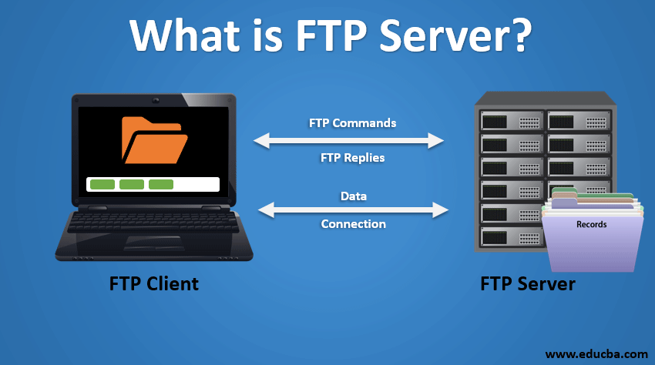

TELNET: Telnet, an acronym for “Teletype Network,” is a network protocol used on the Internet or local area networks. It provides a bidirectional interactive text-oriented communication facility using a virtual terminal connection. The primary purpose of Telnet is to manage devices remotely over the internet or other networks.

Telnet service enables users to login to another computer on

internet from their local computer for using:

◦ Computing power of remote computer

◦ Software on remote computer

◦ Database of remote computer

This action is called ‘remote login.

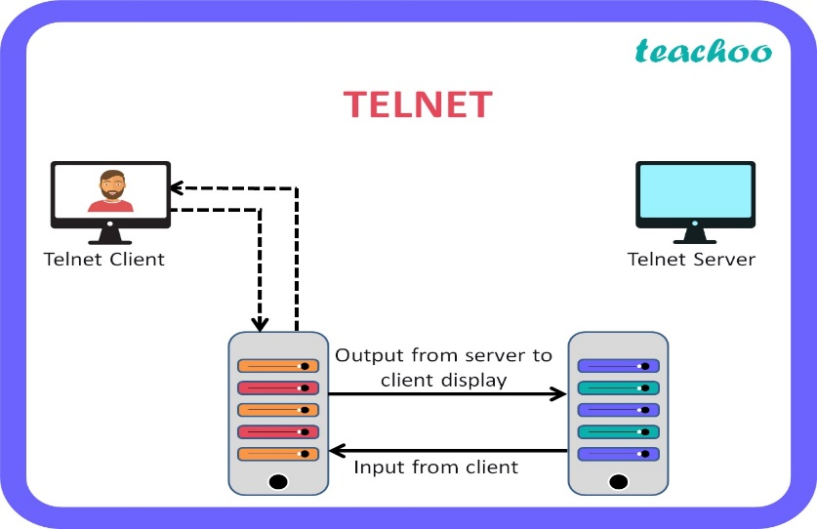

USENET NEWS: Usenet is similar to an online forum or discussion platform where users can discuss various topics in so-called “newsgroups.” Though it enjoyed popularity in the early 1990s, it is now mainly used to share large files between users.

A newsgroup is like a large notice board accessible to all

members belonging to the group.

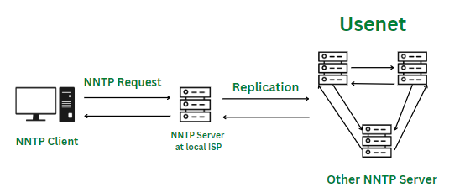

The World Wide Web:

World-Wide Web (also called WWW or W3) is a hypertext-based information system. Any word in a hypertext document can be specified as a pointer to a different hypertext document where more information pertaining to that word can be found.

Uses of the Internet ?

* On-line communication
* Software sharing
* Exchange of views on topics of common interest
* Feedback about product
* On-line journals and magazines
* Customer support service

NETWORK:

The Internet is a global network of billions of computers and other electronic devices. With the Internet, it's possible to access almost any information, communicate with anyone else in the world, and do much more. You can do all of this by connecting a computer to the Internet, which is also called going online.

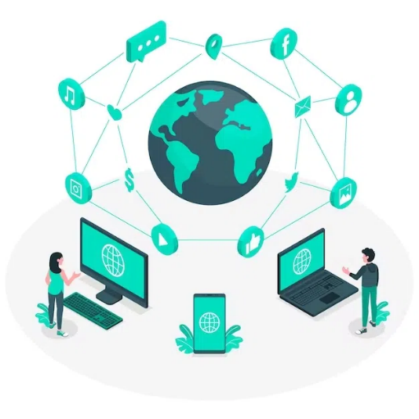

INTERNET REGISTROES:

Internet number resources are distributed globally according to a hierarchical registry system. he Internet Assigned Numbers Authority (department of ICANN) which oversees global IP address allocation, autonomous system number allocation, root zone management in the Domain Name System, media types, and other Internet Protocol-related Services.

DOMAIN NAME:

Domian names are used to identify one or more IP address.very domain name has a suffix that indicates which Top Level Domain(TLD) it belongs to. For example:

com - commercial business

net - Network organizations

gov - Government agencies

Edu - Educational institutions

DNS:

The Domain Name System (DNS) turns domain names into IP addresses, which browsers use to load internet pages. Every device connected to the internet has its own IP address, which is used by other devices to locate the device.

URL:

A URL (Uniform Resource Locator) is the address of a unique resource on the internet. It is one of the key mechanisms used by browsers to retrieve published resources, such as HTML pages, CSS documents, images, and so on.

Network resources are files that can be plain Web pages, other text documents, graphics, or programs. URL strings consist of three parts (substrings):

◦ network protocol

◦ host name or address

◦ file or resource location

URL LOCATION:

The 'location' substring contains a path to one specific network resource on the host. Resources are normally located in a host directory or folder.

URI(Uniform Resource Identifier):

URI is a text which is used to identify any resource or name on Internet. A URL may be a non-persistent sort of the URI. A URN is required to exist globally unique and features a global scope.

INTRANET:

An intranet is a private network contained within an enterprise that is used to securely share company information and computing resources among employees. An intranet can also be used for working in groups and teleconferences. Intranets encourage communication within an organization.

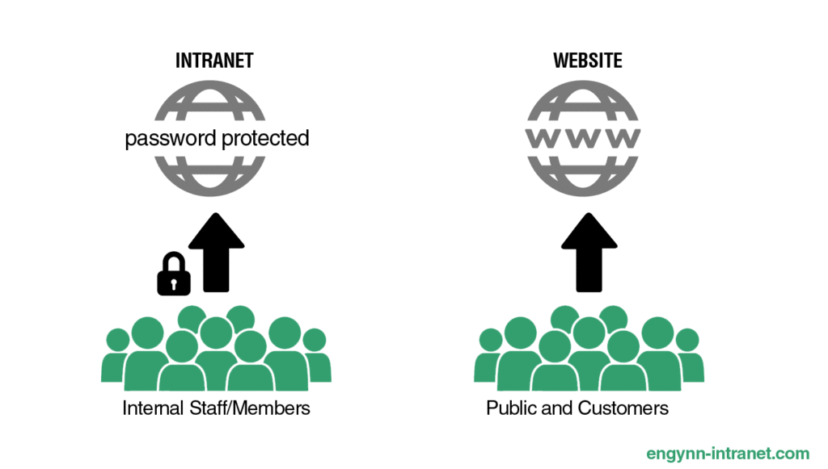

EXTRANET:

An extranet is a private network similar to an intranet, but typically open to external parties, such as business partners, suppliers, key customers, etc. The main purpose of an extranet is to allow users to exchange data and applications, and share information.

